Project Name:  Wastewater Treatment Plant Expansion | Department:  Public Works - Utilities
Type of Project:  Addition of Processing Capacity | Contact:  Chuck Soules
Total Project Cost:
$4,050,000

Description:
The North Force Main conveys all flows generated north of the City’s wastewater treatment plant (WWTP), while the South Force Main performs the same function for the southern portion of the City. The flows from these force mains are directed to the wastewater treatment plant where the water is treated and discharged to the Little Platte River.
The existing wastewater treatment plant utilizes the activated sludge process using Sequencing Batch Reactor (SBR) technology. The plant was originally constructed in 1995 and replaced an existing lagoon system. An expansion was completed to increase the capacity of the WWTP to a 1.125 MGD average daily flow in 2007. The WWTP consists of an influent pump station, Headworks facility, three SBR basins, UV disinfection, effluent pumping, two sludge digester basins, and an excess flow holding tank to store peak flows during wet weather events.

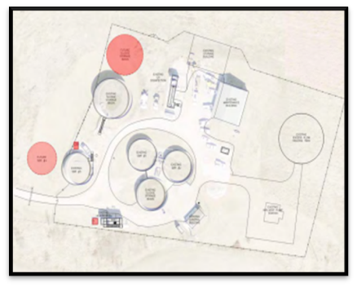
HDR Engineering Inc. prepared the Wastewater Master Plan, and this plan was adopted by the Board of Aldermen in January 2021. The Plant Expansion has been broken up into two phases:
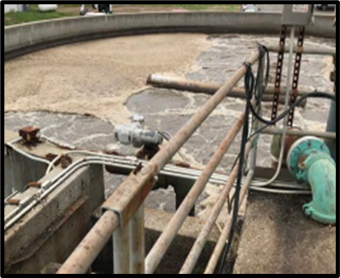
Phase 1: The Phase I expansion, indicated in the figure below, includes expanding the existing plant utilizing Sequencing Batch Reactor treatment technology. The land west of the existing site must be utilized for plant expansion. A fourth SBR basin is required as well as upgrades to the influent valve vault, effluent valve vault, and the addition of an additional sludge storage tank. As shown in the capacity evaluation above, the existing influent pump station, bar screen, UV disinfection, and effluent pump station have sufficient hydraulic capacity to meet the Phase I expansion.

Phase 2: Phase II expansion will require the addition of a fifth and sixth SBR basin. Again, upgrades are required at the influent valve vault and effluent valve vault. Additional bulbs will be added to the UV equipment to increase the design capacity. One more additional sludge storage tank will need to be added to the treatment plant to increase sludge storage capacity

Justification:
The project is identified in the Wastewater Master Plan for system capacity needs. The FY2027 and FY2029 CIP will include CWWS funding for construction related expenses. It is anticipated COP proceeds will be required to finance the construction.

Impact on Operating Costs
The expansion will require more electricity and materials to run the plant as processing capacity increases for all wastewater customers.

Planned Expenditures
 | FY2026 | FY2027 | Total
Engineering | $1,050,000 | - | $1,050,000
Construction | - | $3,000,000 | $3,000,000
Grand Total | $1,050,000 | $3,000,000 | $4,050,000

Funding Sources
 | FY2026 | FY2027 | Total
CWWS | $1,050,000 | $3,000,000 | $4,050,000
Total Net Cost | $1,050,000 | $3,000,000 | $4,050,000

